Common [#kubernetes](https://www.linkedin.com/feed/hashtag/?keywords=kubernetes&highlightedUpdateUrns=urn%3Ali%3Aactivity%3A6991737640182054912) pod issues and how to [#troubleshoot](https://www.linkedin.com/feed/hashtag/?keywords=troubleshoot&highlightedUpdateUrns=urn%3Ali%3Aactivity%3A6991737640182054912) them 🧐  
  
[#k8s](https://www.linkedin.com/feed/hashtag/?keywords=k8s&highlightedUpdateUrns=urn%3Ali%3Aactivity%3A6991737640182054912) has a lot of moving parts and offers wide configuration options. So misconfiguration can happen. The troubleshooting [#flowchart](https://www.linkedin.com/feed/hashtag/?keywords=flowchart&highlightedUpdateUrns=urn%3Ali%3Aactivity%3A6991737640182054912) should give a rough guideline on how to find basic failures in app deployments related to [#pods](https://www.linkedin.com/feed/hashtag/?keywords=pods&highlightedUpdateUrns=urn%3Ali%3Aactivity%3A6991737640182054912) [#replicasets](https://www.linkedin.com/feed/hashtag/?keywords=replicasets&highlightedUpdateUrns=urn%3Ali%3Aactivity%3A6991737640182054912) [#deployments](https://www.linkedin.com/feed/hashtag/?keywords=deployments&highlightedUpdateUrns=urn%3Ali%3Aactivity%3A6991737640182054912) & even [#services](https://www.linkedin.com/feed/hashtag/?keywords=services&highlightedUpdateUrns=urn%3Ali%3Aactivity%3A6991737640182054912) !!

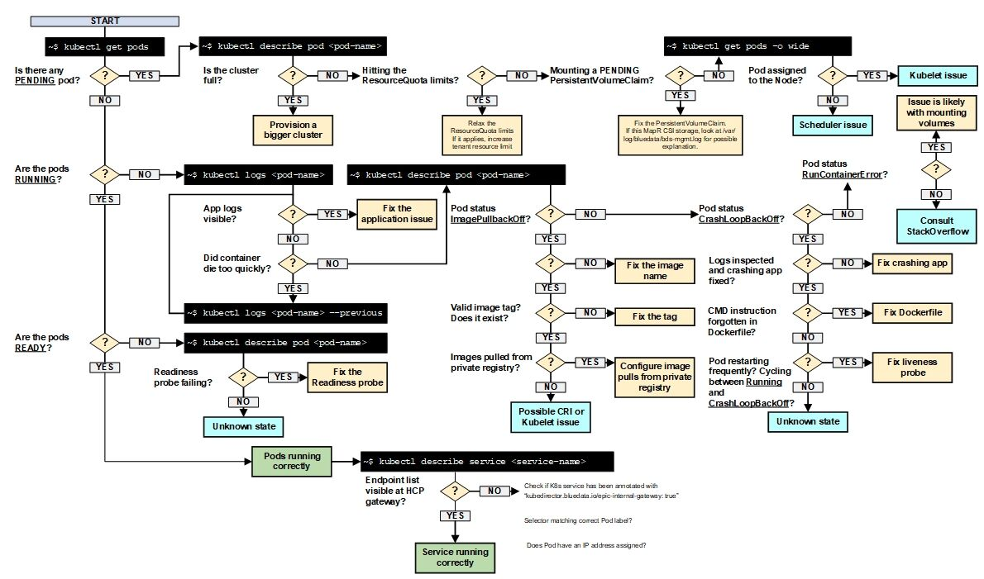

I have been using this open source tool completely on terminal. Just improves the productivity for troubleshooting the k8s in any environment including OpenShift clusters. lots of plugins available.

<https://k9scli.io/>